QNA MODEL FROM SCRATCH RESEARCH & DEVELOPMENT

Model 1: PyTorch Model
Framework: This model is built using PyTorch with GRU layers, and includes a basic encoder-decoder structure. It also uses sentence embeddings for exact match-based answering and a fallback mechanism using direct CSV lookup.
Vocabulary: Created from the training data using token frequency.
Model Size: Around 2 million parameters.
Output Insight: The model is answering a few questions correctly but fails in few cases due to its limited vocabulary and training. It handled only a small dataset with basic logic.
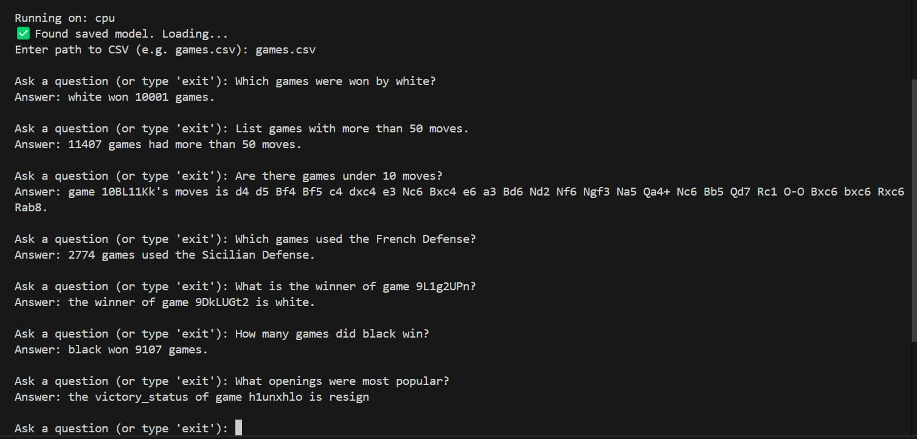
Model 2: TensorFlow Seq2Seq Model
Framework: This model is built from scratch using TensorFlow with an LSTM-based encoder-decoder architecture. It uses a vocabulary size of 15,000, sequence length of 40, and embedding/hidden sizes of 512.
Hyperparameters:
- Epochs: 50
- Validation Split: 0.2
- Sequence Length: 40
- Vocabulary Size: 15,000
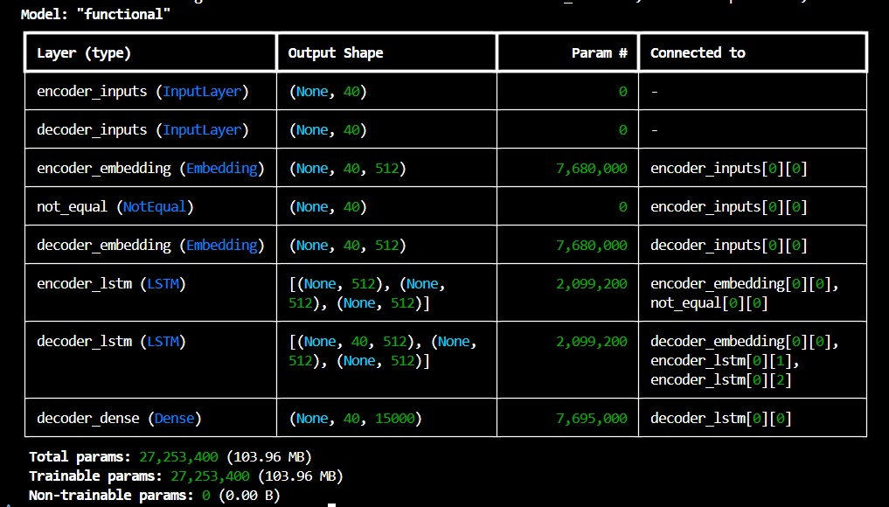
Total Parameter: 27 million
Complexity: The model contains 27 million parameters. Each epoch takes around 8 minutes to train and with 50 epochs, totaling over 7 hours for entire training. The training becomes very resource-intensive, causing high system load.
Output Insight: Despite its complexity, the model often fails to predict meaningful answers due to insufficient learning or underfitting caused by limited data.
High memory usage during training leads to frequent system slowdowns or shutdowns on personal hardware.
Research and References:
The below link explains a similar kind of system modelled by a Master’s Student at San Francisco University. She used similar Seq2Seq model with pre trained embeddings with various mathematical complexities yet achieved a very low accuracy in gaining answers even with huge training data.
https://medium.com/data-science/building-a-question-answering-system-part-1-9388aadff507
Conclusion:
The TensorFlow model was built entirely from scratch, aiming to generate full-sentence answers without relying on pre-trained embeddings. However, such models demand large volumes of training data to learn the structure and semantics of the dataset effectively.
Due to the current dataset's limited diversity and size, the model is unable to generalize well and produces mostly inaccurate or blank answers. Moreover, the computational complexity and memory consumption during training are exceptionally high, causing the system to hang or crash.

